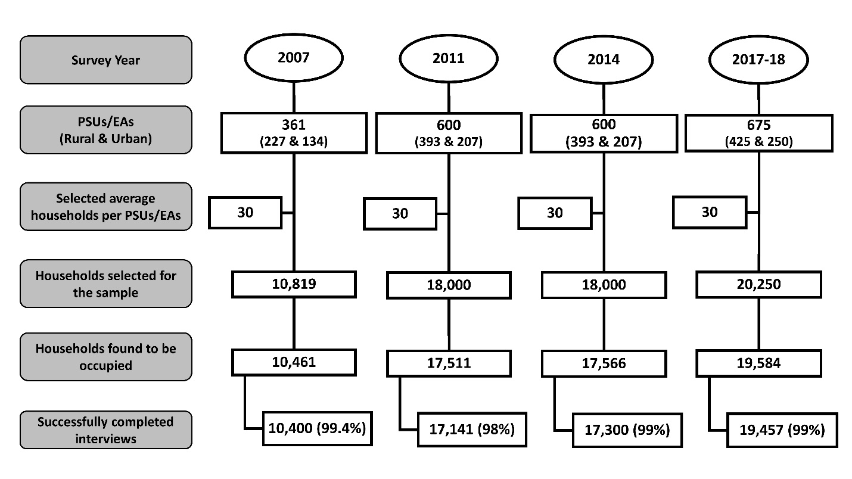

**Supplementary Figure 1: Sampling flowchart for the selection of households for BDHS 2007, 2011, 2014 and 2017-18**

**Supplementary Table 1: Measure of inequality (Concentration Index and 95% Confidence Interval) by survey year**

|  |  |  |  |
| --- | --- | --- | --- |
| Year | Concentration Index (CI) | Standard Error | P value |
| 2007 | 0.57 | 0.01 | <0.05 |
| 2011 | 0.53 | 0.01 | <0.05 |
| 2014 | 0.42 | 0 .01 | <0.05 |
| 2017-18 | 0 .46 | 0.01 | <0.05 |